AZURE ENTERPRISE INFRASTRUCTURE LAB
07 - Azure Alerts
Monitoring and Operational Alerting
Evidence-based implementation documentation with Azure Portal screenshots

1. Objective
Create and document an operational Azure Monitor alert for a meaningful VM condition. The project requirement calls for an alert rule, condition, action group/notification, and alert history.
Current status: The configuration and action-group creation are evidenced, but the supplied screenshots do not yet prove the final alert rule was saved or that an alert fired. Those validation items remain pending.

2. Resource
Setting | Value
VM | vm-web-MM
Monitoring | Azure Monitor
Alert type | Metric/recommended alert
Primary condition | Percentage CPU > 80%
Notification | Email
Estimated monthly alert cost shown | USD $0.00

3. Implementation Flow
- vm-web-MM -> Azure Monitor Alerts
- Condition -> Percentage CPU > 80%
- Notification -> Email / Action Group
- Alert rule -> save and enable
- Alert history -> pending validation

4. Navigation Troubleshooting
The first screenshot opened a Microsoft Entra / Microsoft 365 group named Monitoring Alerts, rather than the Azure Monitor alert blade for the VM. The correct resource path is: Virtual machines -> vm-web-MM -> Monitoring -> Alerts.

5. Alert Configuration
Setting | Final intended value
Resource | vm-web-MM
Signal | Percentage CPU
Operator | Greater than
Threshold | 80%
Notification | Email
Other recommended rules | Disabled
Estimated monthly cost | USD $0.00
The intermediate configuration briefly had both Percentage CPU and Data Disk IOPS enabled. The corrected configuration screenshot shows only the CPU alert enabled and Data Disk IOPS disabled.

6. Action Group
The recommended-alert flow created an action group successfully. The Azure Portal notification explicitly confirms: Action group created successfully. The action group is intended to deliver email notification when the alert triggers.

7. Recommended Alert Rule Details
- Alert name: vm-web-MM-High-CPU
- Description: Alerts when the average VM CPU exceeds 80%.
- Enabled upon creation: Yes

8. Validation Plan
- Confirm the CPU alert rule is saved and visible under vm-web-MM -> Monitoring -> Alerts.
- Confirm the rule is enabled and the email/action group is attached.
- Generate or wait for a CPU threshold breach during testing.
- Capture the alert state and alert history.
- Record the final fired/resolved status in this document.

9. Evidence Checklist
☑ Correct VM Alerts page
☑ CPU threshold condition configured
☑ Email notification enabled
☑ Action group creation success captured
☐ Alert rule saved successfully
☐ Alert fired during validation
☐ Alert history captured
☐ Final resolved/closed state captured

10. GitHub Structure
- 07-monitoring/README.md
- 07-monitoring/screenshots/
- 07-monitoring/screenshots/01-wrong-monitoring-alerts-page.png
- 07-monitoring/screenshots/02-vm-alerts-page.png
- 07-monitoring/screenshots/03-recommended-alerts-initial.png
- 07-monitoring/screenshots/04-cpu-alert-config-corrected.png
- 07-monitoring/screenshots/05-action-group-created.png

11. Git Commit
cd /d C:\azure-enterprise-infrastructure-lab
git add 07-monitoring
git commit -m "Document Azure Monitor CPU alert"
git push

12. Interview Skills Demonstrated
- Azure Monitor and metric alerts
- VM operational monitoring
- CPU threshold alerting
- Notification routing
- Action groups
- Alert lifecycle and history
- Azure Portal troubleshooting
- Cost-aware monitoring

13. Interview Questions
What is an Azure Monitor metric alert?
A rule that evaluates resource metrics against a threshold and can trigger an action when the condition is met.
Why use CPU > 80%?
It is a simple, meaningful operational signal for demonstrating threshold-based alerting on a VM.
What is an action group?
A reusable collection of notification/action settings used when an Azure Monitor alert is triggered.
Why document alert history?
It proves the alert was not only configured but also evaluated and triggered/resolved during validation.

14. Evidence Screenshots
Figure 1 - Initial navigation - incorrect Monitoring Alerts group page (troubleshooting evidence)
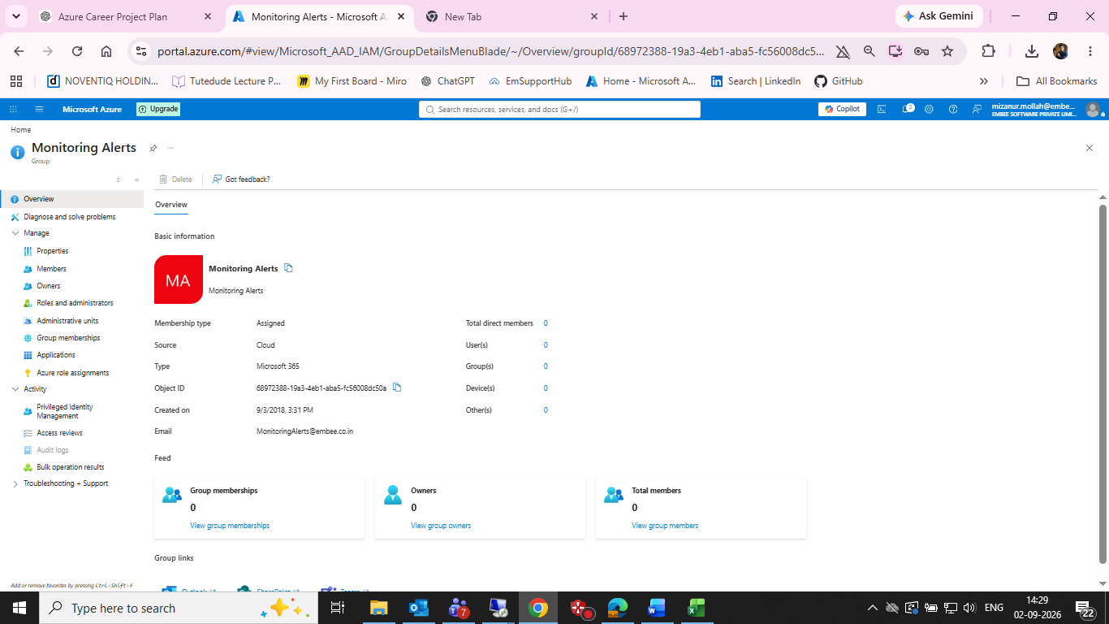
Initial navigation - incorrect Monitoring Alerts group page (troubleshooting evidence)

Figure 2 - Correct Azure Monitor Alerts page for vm-web-MM
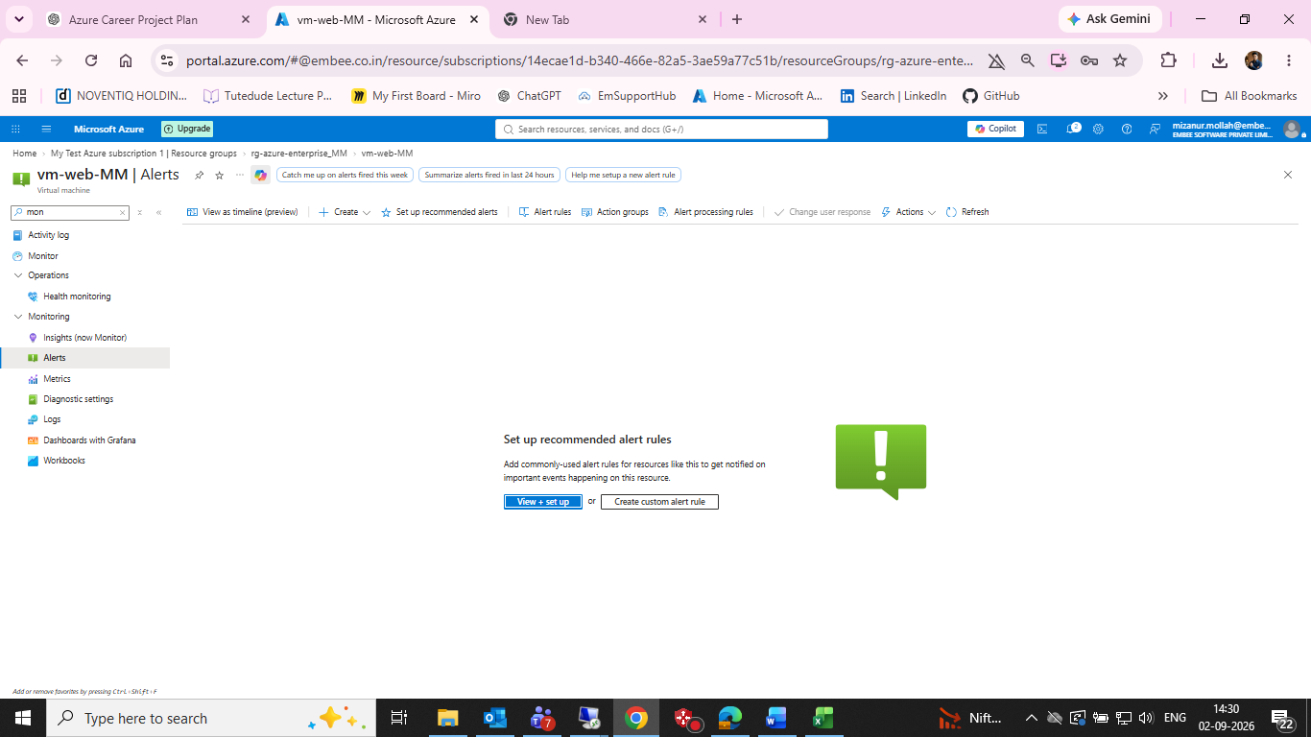
Correct Azure Monitor Alerts page for vm-web-MM

Figure 3 - Recommended alert setup - initial configuration
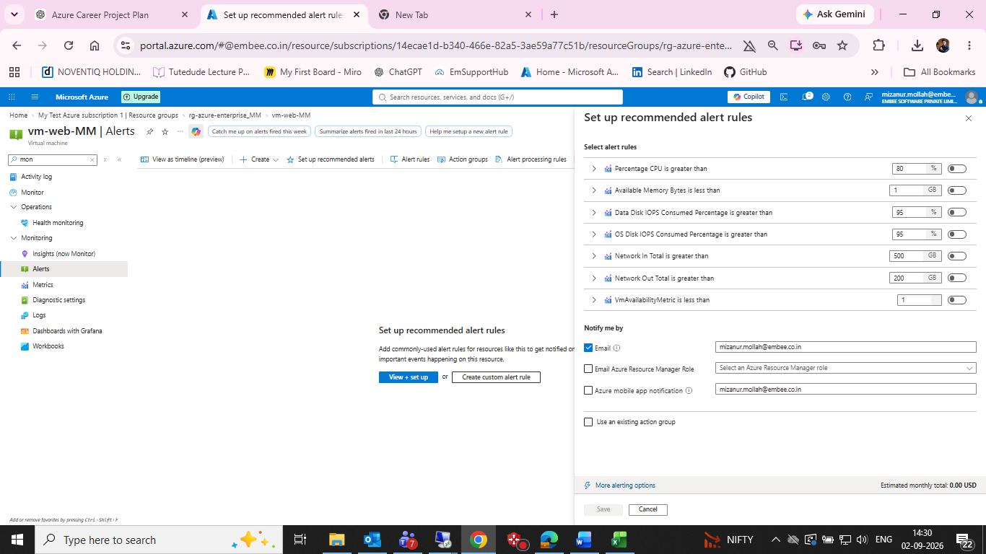
Recommended alert setup - initial configuration

Figure 4 - Corrected alert selection - CPU alert on, Data Disk IOPS off, email enabled
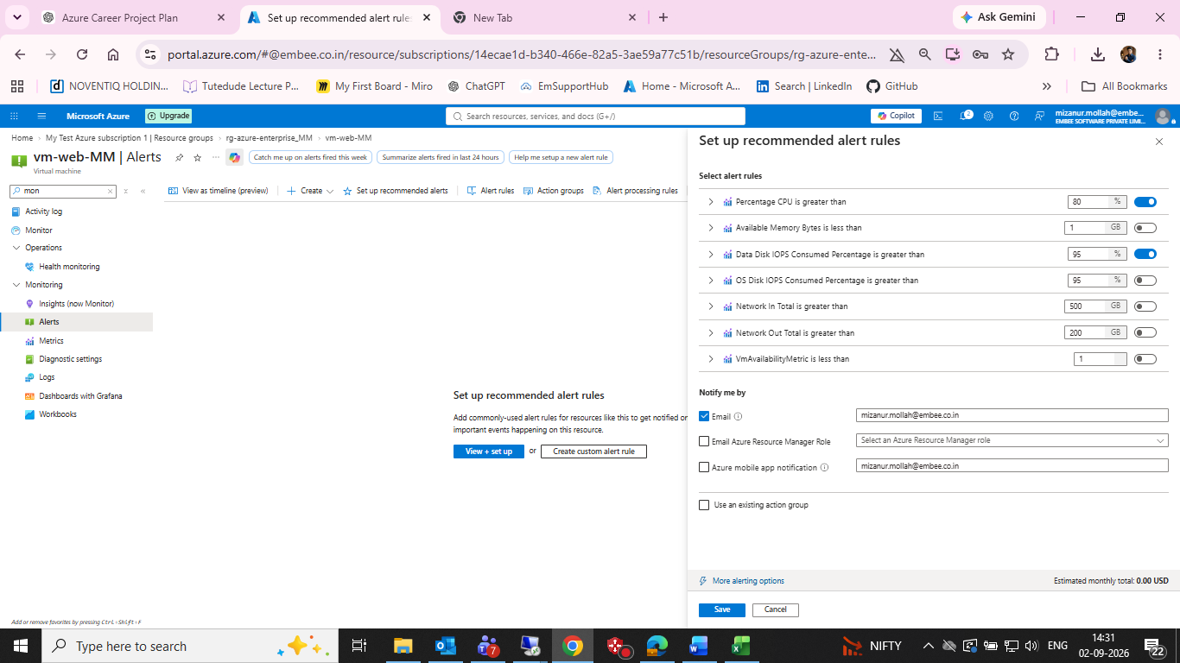
Corrected alert selection - CPU alert on, Data Disk IOPS off, email enabled

Figure 5 - Action group creation success notification
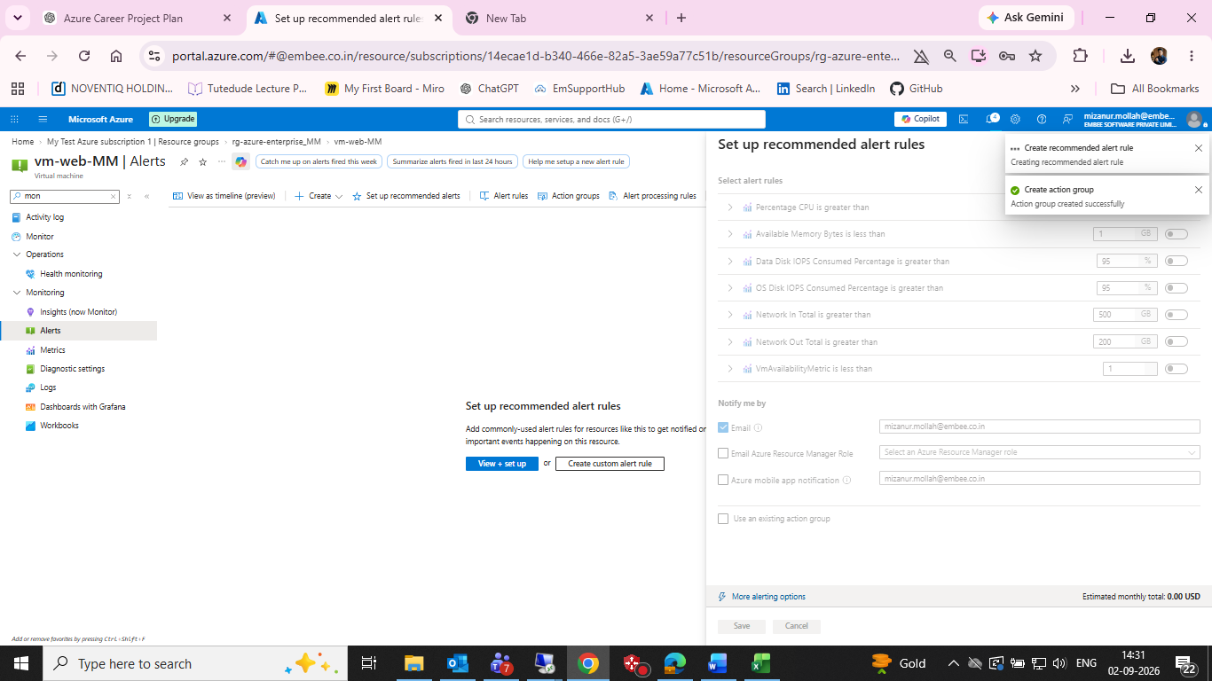
Action group creation success notification

15. Final Status
Task 07 is partially implemented. The correct VM alert blade is reached, the CPU threshold configuration is prepared, email notification is enabled, and the action group creation is confirmed. Final alert-rule creation and fired/resolved alert-history evidence are still required to mark the task fully complete.

